**REVIEW OF LITERATURE:**

**DRUG UTILIZATION RESEARCH**

Drug Utilization Research was defined by WHO in 1977 as “the marketing, distribution, prescription, and use of drugs in a society, with special emphasis on the resulting medical, social and economic consequences” [16].

**HISTORY:**

The development of drug utilization research was sparked by initiatives taken in Northern Europe and the United Kingdom in the mid-1960s [19,20].

The pioneering work of Arthur Engel in Sweden and Pieter Siderius in Holland [21] alerted many investigators to the importance of comparing drug use between different countries and regions.

Their demonstration of the remarkable differences in the sales of antibiotics in six European countries between 1966 and 1967 inspired WHO to organize its first meeting

On “*Drug* consumption” in Oslo in 1969 [22].

This led to the constitution of the WHO European Drug Utilization Research Group (DURG).

After that, drug utilization studies gained popularity.

The pioneers of this research understood that a correct interpretation of data on drug utilization requires investigations at the patient level. It became clear that we need to know the answers to the following questions:

* why drugs are prescribed;
* who the prescribers are;
* for whom the prescribers prescribe;
* whether patients take their medicines correctly;
* what the benefits and risks of the drugs are.

The various domains of drug utilization research are:

* **Pharmacoepidemiology** applies epidemiological methods to studies of the clinical use of drugs in populations. A modern definition of pharmacoepidemiology is “the study of the use and effects/side-effects of drugs in large numbers of people with the purpose of supporting the rational and cost-effective use of drugs in the population thereby improving health outcomes”.
* **Pharmacosurveillance and pharmacovigilance** are terms used to refer to the monitoring of drug safety, for example, by means of spontaneous adverse-effect reporting systems, case-control, and cohort studies.

**PHARMACOEPIDEMIOLOGY**

Pharmacoepidemiology may be drug-oriented, emphasizing the safety and effectiveness of individual drugs or groups of drugs, or utilization-oriented aiming to improve the quality of drug therapy through pedagogic (educational) intervention.

Drug utilization research may also be divided into descriptive and analytical studies. The emphasis of the former has been to describe patterns of drug utilization and to identify problems deserving more detailed studies. Analytical studies try to link data on drug utilization to figures on morbidity, the outcome of treatment, and quality of care with the ultimate goal of assessing whether drug therapy is rational or not.

Sophisticated utilization-oriented pharmacoepidemiology may focus on the drug (e.g., dose-effect and concentration-effect relationships), the prescriber (e.g., quality indices of the prescription), or the patient (e.g., selection of drug and dose, and comparisons of kidney function, drug metabolic phenotype/genotype, age, etc.).

Drug utilization research is thus an essential part of pharmacoepidemiology as it describes the extent, nature, and determinants of drug exposure [23]. Over time, the distinction between these two terms has become less sharp, and they are sometimes used interchangeably. However, while drug utilization studies often employ various sources of information that focus on drugs (e.g., aggregate data from wholesale and prescription registers) the term epidemiology implies defined populations in which drug use can be expressed in terms of incidence and prevalence. Together, drug utilization research and pharmacoepidemiology may provide insights into the following aspects of drug use and drug prescribing:

* **Pattern of use**: This covers the extent and profiles of drug use and the trends in drug use and costs over time.
* **Quality of use**: This is determined using audits to compare actual use to national prescription guidelines or local drug formularies. Indices of quality of drug use may include the choice of drug (compliance with recommended assortment), drug cost (compliance with budgetary recommendations), drug dosage (awareness of inter-individual variations in dose requirements and age-dependence), awareness of drug interactions and adverse drug reactions, and the proportion of patients who are aware of or unaware of the costs and benefits of the treatment.
* **Determinants of use**: These include user characteristics (e.g., sociodemographic parameters and attitudes towards drugs), prescriber characteristics (e.g., specialty, education, and factors influencing therapeutic decisions), and drug characteristics (e.g., therapeutic properties and affordability).
* **Outcomes of use**: These are the health outcomes (i.e., the benefits and adverse effects) and the economic consequences.

The initial focus of pharmacoepidemiology was on the safety of individual drug products (pharmacosurveillance), but it now also includes studies of their beneficial effects. The driving force behind this development was a growing awareness that the health outcomes of drug use in the rigorous setting of randomized clinical trials are not necessarily the same as the health outcomes of drug use in everyday practice. The clinical trials needed to obtain marketing authorization for new drugs involve limited numbers of carefully selected patients, who are treated and followed up for a relatively short time in strictly controlled conditions. As a result, such trials do not accurately reflect how drug use will affect health outcomes in everyday practice under everyday circumstances. Pharmacoepidemiological studies often make useful contributions to our knowledge about effectiveness and safety, because, unlike clinical trials, they assess drug effects in large, heterogeneous populations of patients over longer periods.

Drug utilization research also provides insight into the efficiency of drug use, i.e., whether a certain drug therapy provides value for money and the results of such research can be used to help to set priorities for the rational allocation of health care budgets.

**AIM OF DRUG UTILIZATION RESEARCH:**

The principle aim of DUR is to facilitate the Rational use of drugs in the population. The rational use of drug implies that “Patient receive medications appropriate to their clinical needs, in dose that meet their own individual requirements for the adequate period of time & at the lowest cost to them & their community.

**STEPS IN CONDUCTING DRUG UTILIZATION STUDIES:**

**STEP 1:** Identify drugs or therapeutic areas of practice for inclusion in the program

**STEP 2:** Design of the study

**STEP 3:** Define criteria and standards

**STEP 4:** Design the data collection form

**STEP 5:** Data collection

**STEP 6:** Evaluate results

**STEP 7:** Provide feedback of results

**STEP 8:** Develop & Implement interventions

**STEP 9:** Re-evaluate to determine if drug use has improved

**STEP 10:** Re-asses & revise the DUS program

**STEP 11:** Feedback results

Evaluation is done with the help of

1. Drug utilization metrics
2. Drug use indicators
3. Drug classification system

Drug utilization Metrics:

* Defined daily dose
* Prescribed daily dose

The ultimate goal of drug utilization research must be to assess whether drug therapy is rational or not. To reach this goal, methods for auditing drug therapy towards rationality are necessary. The early work did not permit detailed comparisons of the drug utilization data obtained from different countries because the source and form of the information varied between them. To overcome this difficulty, researchers in Northern Ireland (United Kingdom), Norway, and Sweden developed a new unit of measurement, initially called the agreed daily dose (5) and later the defined daily dose (DDD) (6). This unit was defined as the average maintenance dose of the drug when used on its major indication in adults. The first study used antidiabetic drugs

as an example: it was found that the sum of the DDDs of insulin and oral antidiabetic drugs (about 20 DDDs per1000 inhabitants per day) roughly corresponded to the morbidity due to diabetes after correction for the number of patients

treated with dietary regimens alone. Among the first countries to adopt the DDD methodology was the former Czechoslovakia [24] and the first comprehensive national list of DDDs was published in Norway in 1975 [25]. Another important methodological advance was the adoption of the uniform anatomical therapeutic chemical (ATC) classification of drugs [26,27]. The use of standardized methodology allowed meaningful comparisons of drug use in

different countries to be made.

Drug use indicators:

Prescribing indicators:

1. Total number of drug prescribed
2. Average number of drugs per prescription
3. Percentage of patients with an injection prescribed
4. Percentage of drugs prescribed from national essential drug list
5. Percentage of patients prescribed with antibiotic

Patient care indicators:

1. Average consulting time
2. Average dispensing time
3. Percentage of drugs actually dispensed
4. Percentage of drugs adequately labelled
5. Patient knowledge of correct dosage

Facility indicators:

1. Availability of copy of essential drugs list or formulary
2. Availability of key drugs

Complementary drug use indicators:

1. Percentage of patients treated without drugs
2. Average drug cost per encounter
3. Percentage of drug costs spent on antibiotics
4. Percentage of drug costs spent on injections
5. Prescription in accordance with treatment guideline

**DRUG CLASSIFICATION SYSTEM:**

A drug classification system represents a common language for describing the drug assortment in a country or region and is a prerequisite for national and international comparisons of drug utilization data, which have to be collected and aggregated in a uniform way. Access to standardized and validated information on drug use is essential to allow audits of patterns of drug utilization, identify problems in drug use, initiate educational or other interventions, and monitor the outcomes of these interventions. The main purpose of having an international standard is to be able to compare data between countries.

Drugs can be classified in different ways according to:

* their mode of action;
* their indications; or
* their chemical structure.

Each classification system will have its advantages and limitations and its usefulness will depend on the purpose, the setting used, and the user’s knowledge of the methodology. Comparisons between countries may require a classification system different from that needed for a local comparison (e.g., between different wards in a hospital). Of the various systems proposed over the years, only two have survived to attain a dominant position in drug utilization research worldwide. They are:

1. Anatomical Therapeutic (AT) classification developed by the European Pharmaceutical Market Research Association (EPhMRA) EPhMRA system.
2. Anatomical Therapeutic Chemical (AT) classification developed by the Norwegian researchers

**PRESCRIPTION PATTERN STUDIES** [28]

Prescription is legal document comprising instructions for use of medications by a licensed medical practitioner to the pharmacist. [29] Correct prescription has a tremendous influence on drug therapy as well as patient’s health. Prescription error was found to account for 70% of medication errors. [30]

Prescription pattern monitoring studies (PPMS) are a part of drug utilization studies with the main focus on prescribing, dispensing and administering of drugs. They promote appropriate use of drugs and reduction of abuse or misuse of monitored drugs. PPMS also guide and support prescribers, dispensers and the general public on appropriate use of drugs, collaborate and develop working relationship with other key organizations to achieve a rational use of drugs. Prescription Patterns explain the extent and profile of drug use, trends, quality of drugs, and compliance with regional, state or national guidelines like standard treatment guidelines, usage of drugs from essential medicine list and use of generic drugs. There is increasing importance of PPMS because of a boost in marketing of new drugs, variations in pattern of prescribing and consumption of drugs, growing concern about delayed adverse effects, cost of drugs and volume of prescription. The aim of PPMS is to facilitate the rational use of drugs in a population.

**CORONARY ARTERY DISEASE**:

Cardiovascular diseases are major causes of mortality and disease in the Indian subcontinent, causing more than 25% of deaths [31]. Coronary artery disease is a condition in which there is an inadequate supply of blood and oxygen to the myocardium. It results from occlusion of the coronary arteries and results in a demand-supply mismatch of oxygen. It typically involves the formation of plaques in the lumen of coronary arteries that impede blood flow [32].

Coronary artery disease is a multifactorial phenomenon. Etiologic factors can be broadly categorized into non-modifiable and modifiable factors. Non-modifiable factors include gender, age, family history, and genetics. Modifiable risk factors include smoking, obesity, lipid levels, and psychosocial variables. In the Western world, a faster-paced lifestyle has led people to eat more fast foods and unhealthy meals which has led to an increased prevalence of ischemic heart diseases.

The male gender is more predisposed than the female gender. Hypercholesterolemia remains an important modifiable risk factor for CAD. Increased low-density lipoproteins (LDL) increased the risk for CAD and elevated high-density lipoproteins (HDL) decrease the incidence of CAD. An individual's 10-year risk of atherosclerotic cardiovascular disease can be calculated using the ASCVD equation available online on the American Heart Association portal. Markers of inflammation are also strong risk factors for coronary artery disease.

Coronary artery disease is very common in both developed and developing worlds.

The hallmark of the pathophysiology of CAD is the development of atherosclerotic plaque. Plaque is a build-up of fatty material that narrows the vessel lumen and impedes the blood flow. The first step in the process is the formation of a "fatty streak." Fatty streak is formed by subendothelial deposition of lipid-laden macrophages, also called foam cells. When a vascular insult occurs, the intima layer breaks, and monocytes migrate into the subendothelial space where they become macrophages. These macrophages take up oxidized low-density lipoprotein (LDL) particles, and foam cells are formed. T cells get activated, which releases cytokines only to aid in the pathologic process. Growth factors released activate smooth muscles, which also take up oxidized LDL particles and collagen and deposit along with activated macrophages and increase the population of foam cells. This process leads to the formation of subendothelial plaque.

Over time, this plaque could grow in size or become stable if no further insult occurs to the endothelium. If it becomes stable, a fibrous cap will form, and the lesion will become calcified over time. As time passes, the lesion can become hemodynamically significant enough that not enough blood would reach the myocardial tissue at the time of increased demands, and angina symptoms would occur. However, symptoms would abate at rest as the oxygen requirement comes down. For a lesion to cause angina at rest, it must be at least 90% stenosed. Some plaques can rupture and lead to exposure of tissue factor, which culminates in thrombosis. This thrombosis could cause subtotal or total occlusion of the lumen and could result in the development of acute coronary syndrome (ACS) in the form of unstable angina, NSTEMI, or STEMI, depending on the level of insult.[[33]](https://www.ncbi.nlm.nih.gov/books/NBK564304/)

Classification of coronary artery disease is typically done as under:

1. Stable ischemic heart disease (SIHD)
2. Acute coronary syndrome (ACS)
   1. ST-elevation MI (STEMI)
   2. Non-ST elevation MI (NSTEMI)
   3. Unstable angina

Echocardiography is an ultrasound of the heart. It is a useful and non-invasive mode of testing that is performed in both acute and chronic and inpatient and outpatient settings. In acute settings, it could tell about wall motion, valvular regurgitation and stenosis, infective or autoimmune lesions, and chamber sizes. It also is useful in the diagnosis of acute pulmonary pathologies like pulmonary embolism. It also evaluates the pericardial cavity. In chronic settings, it can be done to see the same information mentioned above and also a response to the therapy. It also is used in an outpatient setting as part of stress testing. In addition to diagnostics, it also has a role in therapeutics for example, pericardiocentesis could be performed with the needle-guided by echocardiography. This test is user-dependent and could be costly compared to ECG.[[34]](https://www.ncbi.nlm.nih.gov/books/NBK564304/)

The treatment of patients has three goals: 1) minimize or eliminate ischemia (silent or symptomatic), 2) reduce morbidity, and 3) decrease mortality.

The management includes risk factor management along with medications

**Risk factor management**

Managing risk factors for CAD can help slow down the progression of your disease.

* Diabetes – Antidiabetic drugs
* High blood pressure – Anti hypertensive drugs
* High cholesterol & triglycerides (hypertriglyceridemia)- hypolipidemic drugs.
* Overweight/obesity- life style modifications.

**Medications**

* Medications to manage stable angina – antianginal drugs.
* Medications to reduce risk of blood clots – antiplatelet drugs & anticoagulant drugs.
* Medications to reduce work load of heart and treat heart failure – Diuretics & drugs for treating heart failure
* Medications for treating/preventing Acid peptic disease/GERD- PPI/H2 Blockers/Antacids
* Miscellaneous drugs such as Vitamins,Laxatives,sedatives.

ASPIRIN:

Antiplatelet drugs are classiﬁed on the basis of their site

of action, that is, drugs that inhibit (i) platelet adhesion, (ii)

platelet activation, (iii) platelet aggregation, and (iv) platelet-

mediated links with inﬂammation [87]. Aspirin belongs to

the group of drugs that inhibit platelet activation. As seen

before, platelet activation can be blocked by inhibited the

Aspirin is a cyclooxygenase-1 (COX-1) inhibitor. It is a modifier of the enzymatic activity of cyclooxygenase-2 (COX-2)

Antiplatelet drugs are classiﬁed on the basis of their siteof action, that is, drugs that inhibit (i) platelet adhesion, (ii)platelet activation, (iii) platelet aggregation, and (iv) platelet-mediated links with inﬂammation [35]. Aspirin belongs tothe group of drugs that inhibit platelet activation. As seenbefore, platelet activation can be blocked by inhibited theTXA2pathway, ADP pathway, thrombin pathway, and phos-phodiesterase (PDE). Aspirin meets its eﬀects by inhibitingthe TXA2pathway in a dose-dependent manner.Low-dose (75–81 mg) aspirin inhibits cycloxygenase-1(COX-1) in such a way that only TXA2production is inhib-ited and not of PGI2. Gastrointestinal tract (GIT) bleeding,drug interactions, and resistance are major drawbacks of aspirin.

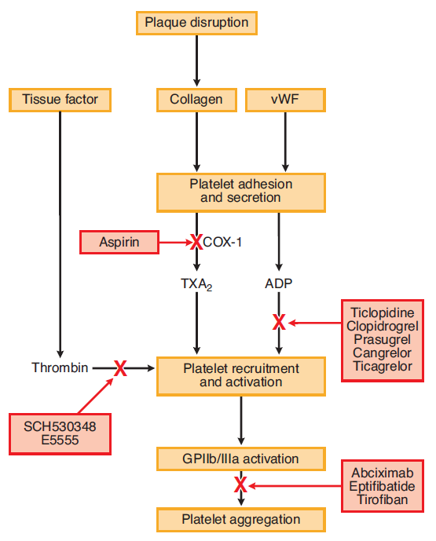

It is available in different doses

* Tablet: 325 mg, 500 mg
* Delayed-release tablet: 81 mg, 325 mg, 500 mg, 650 mg
* Chewable: 81 mg
* Suppository: 60 mg, 120 mg, 200 mg, 300 mg, 600 mg
* Intravenous: 250 mg, 500 mg

Almost 90% of COX inhibition can be achieved with the administration of 160 to 325 mg of aspirin. These effects last for about 7 to 10 days which usually correspond with the lifespan of a platelet. Prostacyclin inhibition can be achieved with the use of higher doses. This inhibition occurs in the endothelial cells of blood vessels.

 Aspirin therapy is associated with bleeding, idiosyncratic, and allergic drug reactions.[[36]](https://www.ncbi.nlm.nih.gov/books/NBK564304/)

## Contraindications

1. People who are allergic to ibuprofen
2. increases the risk of GI bleeding in patients who already suffer from peptic ulcer disease or gastritis.
3. Patients who have glucose-6-phosphate dehydrogenase deficiency are at risk of acute intravascular hemolytic anemia.
4. Avoid using aspirin in children who are suffering from a viral infection to avoid Reye syndrome.

CLOPIDOGREL:

**Clopidogrel** is FDA approved for the medical management of unstable angina (UA)/non-ST-segment elevation myocardial infarction (NSTEMI), ST-segment elevation myocardial infarction (STEMI) in patients receiving fibrinolytic therapy, and for secondary prevention in recent myocardial infarction (MI), recent stroke, and peripheral arterial disease.

Upon activation, clopidogrel exhibits its pharmacodynamic effect by specifically and irreversibly binding to P2Y12, a subtype of the adenosine diphosphate (ADP) receptor, on the surface of platelets [37,38]. P2Y12 is a Giprotein-coupled receptor. Activation of the P2Y12 receptor triggers a complex cascade of intracellular events, resulting in reduced protein kinase A (PKA) phosphorylation of vasodilator-stimulated phosphoprotein (VASP) and subsequent activation of the glycoprotein (GP) IIb/IIIa receptor, granule release, amplification of platelet aggregation and stabilization of the platelet aggregate. Irreversible binding of clop-AM to the P2Y12 receptor consequently results in inactivation of the GP IIb/IIIa receptor and destabilization of the thrombus for the lifespan of the platelets.

Since gastrointestinal bleeding is a common side effect of clopidogrel, in particular when combined with aspirin,proton pump inhibitors (PPIs) are often co-prescribed with clopidogrel and aspirin, which has been shown to significantly decrease drug-induced gastrointestinal bleeding.

Clopidogrel is often co-prescribed with 3-hydroxy-3-methylglutaryl-coenzyme A (HMG-CoA) reductase inhibitors or statins.

Two clinical studies reported that continuous treatment with atorvastatin 80 mg significantly enhanced clopidogrel bioactivation and efficacy in both healthy volunteers and PCI patients with or without DM [39, 40].

**HEPARIN:**

Heparin is an essential drug and is the most widely used clinical anticoagulant worldwide [41]. Heparin is a highly sulfated glycosaminoglycan. UFH is extracted and purified from animal tissues including porcine intestine and bovine lung and intestine. LMWH is produced through the controlled depolymerization of UFH. ULMWH is a synthetic specific pentasaccharide, which is similar to a pentasaccharide sequence found within UFH and LWMH. Heparin was discovered in 1916 by medical student Jay McLean [42].

Heparins work by primarily inhibiting thrombin (FIIa) and/or FXa. By inactivating thrombin, it blocks the conversion of fibrinogen to fibrin; this prevents the formation of clots and prolongs the clotting time of blood.

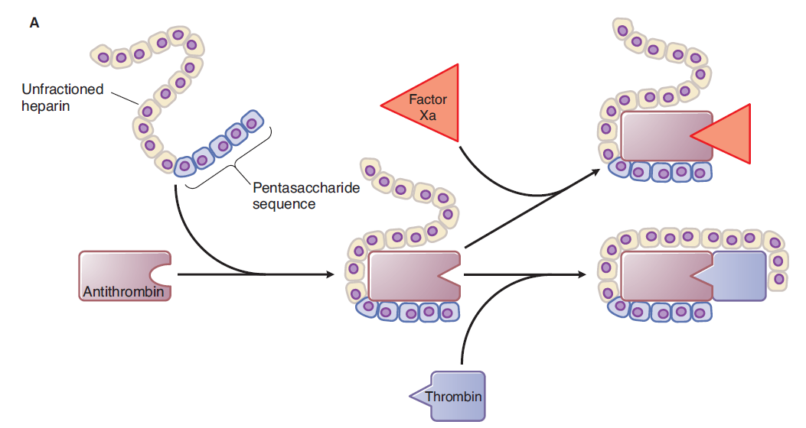





Heparin is administrated by intravenously or subcutaneously and the level of heparin in the circulation is monitored by the activated partial thromboplastin time assay.

When administered SQ, the onset of action is usually within 1 to 2 hours compared to an immediate anticoagulant effect with IV administration of heparin.

Heparin use's typical adverse effects include bleeding, thrombocytopenia, injection site reactions, hyperkalemia, alopecia, and osteoporosis. Osteopenia and osteoporosis have correlations with chronic heparin use, but not with acute use of heparin.

## Contraindications

A patient should not receive heparin if:

* The platelet count is 100,000/mm or lower.
* The patient cannot have routine monitoring tests performed to monitor therapeutic heparin.
* The patient has an active, uncontrollable bleed except for disseminated intravascular coagulation (DIC).
* Patients with a history of heparin-induced thrombocytopenia should also avoid heparin use.

**ATORVASTATIN:**

Atorvastatin competitively inhibits 3-hydroxy-3-methylglutaryl-coenzyme A (HMG-CoA) reductase.[[43]](https://www.ncbi.nlm.nih.gov/books/NBK430779/) By preventing the conversion of HMG-CoA to mevalonate, statin medications decrease cholesterol production in the liver. Atorvastatin also increases the number of LDL receptors on the surface of hepatic cells.

In combination with dietary modifications, atorvastatin is FDA approved to prevent cardiovascular events in patients with cardiac risk factors and for patients with abnormal lipid profiles.[[44]](https://www.ncbi.nlm.nih.gov/books/NBK430779/)

Primary prevention[45]:

For patients without coronary heart disease but with multiple risk factors, the FDA has approved atorvastatin to reduce the risk of myocardial infarction, stroke, revascularization procedures, and angina.

For patients diagnosed with type 2 diabetes mellitus without coronary heart disease but with multiple risk factors, atorvastatin has FDA approval to reduce the risk of myocardial infarction and stroke.

Secondary prevention[45]:

For patients with coronary heart disease, atorvastatin has approval as a therapy to reduce the risk of non-fatal myocardial infarction, fatal and non-fatal stroke, revascularization procedures, hospitalizations for congestive heart failure, and angina

Statin therapy can cause myalgias, diarrhea, and arthralgias among side effects[46].

DRUG INTERACTIONS:

The use of atorvastatin with potent CYP3A4 inhibitors can lead to increased plasma concentrations, which may enhance adverse events, including myopathies.

CYP3A4 inducers may cause decreased plasma concentrations of atorvastatin.

Patients taking digoxin should undergo monitoring when starting atorvastatin as plasma concentrations of digoxin may increase.

Atorvastatin may also increase drug exposure of norethindrone and ethinyl estradiol

**ROSUVASTATIN:**

Rosuvastatin is a fully synthetic HMG-CoA reductase

inhibitor. Other HMG-CoA reductase inhibitors are

either natural, mevinic acid derived (lovastatin, simvas-

tatin, pravastatin) or synthetic, heptenoic acid derived

(atorvastatin, uvastatin). Rosuvastatin belongs to a

Rosuvastatin is a fully synthetic HMG-CoA reductase

inhibitor. Other HMG-CoA reductase inhibitors are

either natural, mevinic acid derived (lovastatin, simvas-

tatin, pravastatin) or synthetic, heptenoic acid derived

(atorvastatin, uvastatin). Rosuvastatin belongs to a

Rosuvastatin is a fully synthetic HMG-CoA reductase

inhibitor. Other HMG-CoA reductase inhibitors are

either natural, mevinic acid derived (lovastatin, simvas-

tatin, pravastatin) or synthetic, heptenoic acid derived

(atorvastatin, uvastatin). Rosuvastatin belongs to a

Rosuvastatin is a fully synthetic HMG-CoA reductase inhibitor. Other HMG-CoA reductase inhibitors are either natural, mevinic acid derived (lovastatin, simvas-tatin, pravastatin) or synthetic, heptenoic acid derived (atorvastatin, fluvastatin). Rosuvastatin belongs to a new generation of methane- sulphonamide pyrimidine and N-methane sulfonyl pyrrole-substituted 3, 5- dihydroxy-heptenoates. Although the characteristic statin pharmacophore remains similar to other statins, the addition of a stable polar methane-sulphonamide group provides low lipophilicity and enhanced ionic interaction with HMG-CoA reductase enzyme thus improving its binding affinity to this enzyme.[47,48,49]

The mechanism of action of rosuvastatin is inhibition of 3-hydroxy-3-methyl-glutaryl coenzyme A (HMG-CoA) reductase. This enzyme is the rate-limiting step in cholesterol synthesis, which reduces the production of mevalonic acid from HMG-CoA.

DOSE:5 mg, 10 mg, 20 mg, 40 mg

## Contraindications

* Pregnancy (pregnancy category X)
* Breastfeeding
* Active liver disease
* Unexplained persistent elevations of serum transaminases

**ISOSORBIDE DI NITRATE:**

Isosorbide dinitrate (ISDN) is an organic nitrate effective against angina pectoris when

given either sublingually [50] or orally [51,52].

Isosorbide is a nitrate that exerts its pharmacologic effect by releasing nitric oxide (NO), an endothelium-derived relaxing factor (EDRF).NO is endogenously produced in the endothelium to dilate the blood vessels. Isosorbide undergoes bioactivation in the endoplasmic reticulum through the cytochrome P450 enzymes to release NO, which activates the enzyme soluble guanylyl cyclase in the vascular smooth muscles, thereby increasing the levels of intracellular cGMP and the associated protein kinases such as cGMP- dependent protein kinases(cGK-I). The cGMP activates the myosin light chain phosphatase (MLCP), causing dephosphorylation of the myosin light chain. cGMP-cGK-I inhibits the inositol-1,4,5-trisphosphate (IP3)-dependent calcium release, decreasing the intracellular calcium.

The decreased intracellular calcium inhibits the myosin light chain kinase(MLCK). The MLCK, along with the unphosphorylated myosin light chain, causes the myosin head to detach from the actin component of the smooth muscle, resulting in smooth muscle relaxation and causing vasodilation. Isosorbide dilates the venous capacitance vessels, arterioles, and coronary arteries. But Its maximal effect is seen in venous capacitance vessels.

DOSE: sublingual - 2.5 to 10 mg

The adverse effects of isosorbide are:

* Headache
* Reflex tachycardia
* Orthostatic hypotension
* Hypotension
* Cutaneous flushing
* Nausea, vomiting
* Dizziness
* Lightheadedness
* syncope

CONTRAINDICATION:

* Concomitant use of isosorbide with PDE inhibitors such as sildenafil and tadalafil
* Concomitant use of isosorbide with riociguat, a soluble guanylate cyclase stimulator used for the treatment of pulmonary arterial hypertension and chronic thromboembolic pulmonary hypertension
* Right ventricular infarction
* Hypertrophic cardiomyopathy

ENOXAPARIN:

Enoxaparin is low molecular weight heparin (LMWH) and was first approved for medical use in 1993 and is derived from heparin. It has approval for the following clinical conditions - acute coronary syndromes, deep venous thrombosis (DVT) treatment and prophylaxis, treatment for pulmonary embolism (PE), venous thromboembolism (VTE) treatment and prophylaxis in a variety of scenarios, percutaneous coronary intervention (PCI), and periprocedural anticoagulation, among others[53].

Enoxaparin is a type of low molecular weight heparin (LMWHs) with a mean molecular weight of 4000 to 5000. It has an immediate onset of action when given in the intravenous form. It binds to and potentiates antithrombin III, a serine protease inhibitor, to form a complex that irreversibly inactivates factor Xa.[[54]](https://www.ncbi.nlm.nih.gov/books/NBK539865/) Enoxaparin has less activity against factor IIa (thrombin) compared to unfractionated heparin.

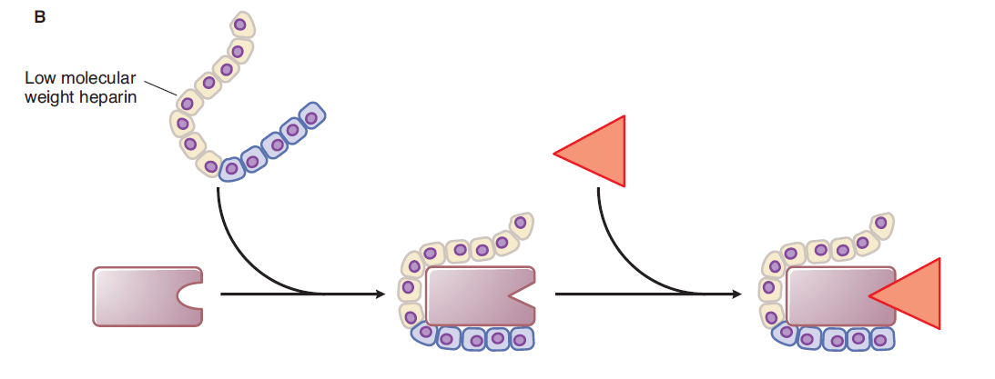





 Following are the few side effect of enoxaparin[[55][56]](https://www.ncbi.nlm.nih.gov/books/NBK539865/):

* Bleeding; most common adverse effect
* Heparin-induced thrombocytopenia, though less common than conventional heparin
* Injection site hemorrhage or pain
* Nausea, confusion, headache
* Hypoaldosteronism
* Gastrointestinal bleeding
* Rectal sheath hematoma
* Liver injury

WARFARIN:

Warfarin is a medication used in the prophylaxis and treatment of venous thrombosis and thromboembolic events. It is in the anticoagulant class of drugs. This activity reviews the indications, action, and contraindications for warfarin as a valuable agent in the prophylaxis and treatment of myocardial infarction, deep vein thrombosis, pulmonary embolism, and atrial fibrillation[57].

Warfarin competitively inhibits the vitamin K epoxide reductase complex 1 (VKORC1), an essential enzyme for activating the vitamin K available in the body. Through this mechanism, warfarin can deplete functional vitamin K reserves and thereby reduce the synthesis of active clotting factors. The hepatic synthesis of coagulation factors II, VII, IX, and X, as well as coagulation regulatory factors protein C and protein S, require the presence of vitamin K. Vitamin K is an essential cofactor for the synthesis of all of these vitamin K-dependent clotting factors.

Warfarin is a once-daily oral medication.

Serious adverse effects of warfarin include bleeding and significant hemorrhage.

Rare cases of purple toe syndrome, warfarin-induced skin necrosis, and there are reports of calciphylaxis with warfarin therapy.[[58][59]](https://www.ncbi.nlm.nih.gov/books/NBK470313/)

FENOFIBRATE:

Fenofibrate is a lipid-regulating drug which is structurally related to other fibric acid derivatives, such as clofibrate. At the recommended dosage of 200 to 400 mg daily, it produces substantial reductions in plasma triglyceride levels in hypertriglyceridaemic patients and in plasma total cholesterol levels in hypercholesterolaemic patients. High density lipoprotein (HDL)-cholesterol levels are generally increased in patients with low pretreatment values. Fenofibrate appears to be equally effective in diabetic patients with hyperlipoproteinaemia without adversely affecting glycaemic control. The influence of fenofibrate on the plasma lipid profile is sustained during long term (2 to 7 years) treatment[60].

NITROGLYCERINE:

Nitroglycerin is a vasodilatory drug used primarily to provide relief from anginal chest pain. It is currently FDA approved for the acute relief of an attack or acute prophylaxis of angina pectoris secondary to coronary artery disease[61]

Although nitroglycerin has a vasodilatory effect in both arteries and veins, the profound desired effects caused by nitroglycerin are primarily due to venodilation.[[62]](https://www.ncbi.nlm.nih.gov/books/NBK482382/) Venodilation causes pooling of blood within the venous system, reducing preload to the heart, which causes a decrease in cardiac work, reducing anginal symptoms secondary to demand ischemia. Arterial vasodilation will still occur and contribute to the relief of anginal symptoms.[[63][64]](https://www.ncbi.nlm.nih.gov/books/NBK482382/)

Nitroglycerin has many adverse effects of significance, most resulting from the vasodilatory effects of the medication.[[65][66]](https://www.ncbi.nlm.nih.gov/books/NBK482382/) These include:

* Dizziness
* Weakness
* Palpitations
* Vertigo
* Headaches
* Nausea
* Vomiting
* Diaphoresis
* Syncope

RANOLAZINE:

Ranolazine is a late sodium channel blocker approved in 2006 for treatment of chronic stable angina.[67]

At the therapeutic level, it inhibits the late phase of inward sodium channels in ischemic cardiac myocytes, reducing the intracellular sodium concentration and thus reducing intracellular calcium influx via the Na-Ca channel. Decreased intracellular calcium reduces ventricular wall tension and thus reduces oxygen consumption. It does not affect blood pressure or heart rate.

Ranolazine is available as 500 mg and 1000 mg extended-release tablets.

ADVERSE EFFECTS: The most common adverse events were dizziness, headaches, nausea, debility, and constipation.

## Contraindications

Ranolazine is metabolized in the liver mainly by CYP3A4  and CYP2D6 enzymes.

So drugs metabolized by these enzymes are contraindicated.

TRIMETAZIDINE:

Trimetazidine (TMZ) is a well-known anti-ischemic agent used for the treatment of angina pectoris.

Trimetazidine is used in combination with other drugs for the symptomatic treatment of stable angina pectoris, chest pain caused by decreased oxygen supply due to reduced blood flow to the heart. This medicine is used when patients do not respond adequately to other agents or are intolerant to first line anti-anginal agents

NICORANDIL:

It is also used for patients in whom the pain is not adequately controlled by other agents

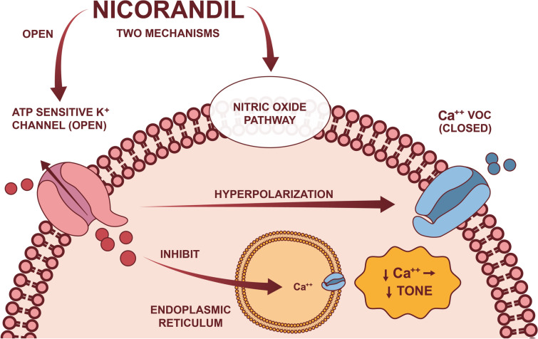

Other effects of nicorandil have been proposed, such as reduced atherosclerosis and plaque necrosis [68], anti-platelet properties and protection against long-term endothelial dysfunction [69, 70]

IVABRADINE:

Ivabradine is a novel medication approved for the treatment of coronary artery disease (CAD) and heart failure (HF). It exhibits a negative chronotropic effect induced by the selective inhibition of the funny current channels of the sinoatrial (SA) node.[71]

The most common adverse effects include bradycardia, atrial fibrillation, high blood pressure, and phosphenes.

Ivabradine is metabolized by CYP3A4.

## Contraindications

Ivabradine is contraindicated in the following situations:

* Decompensated heart failure
* Blood pressure less than 90/50
* Conduction abnormalities, e.g., sick sinus syndrome, sinoatrial block, or third-degree AV block, unless a pacemaker determines the heart rate
* Severe liver impairment
* Patients taking cytochrome P450 3A4 (CYP3A4) inhibitors
* Resting heart rate less than 60 before therapy initiation

FUROSEMIDE:

The first loop diuretic was a medication called furosemide. It works by blocking the Na+ K+ 2Cl- symporter in the thick ascending limb of the loop of Henle and preventing it from performing its role, effectively stopping salt transport in this area of the nephron. Due to a decrease in plasma volume and cardiac output, furosemide lowers blood pressure. This phenomenon is known as "postdiuretic Na+ retention" and can be treated by administering loop diuretics on a regular basis and following a salt-restricted diet. As the concentration of loop diuretic in the tubular lumen decreases, nephrons begin to reabsorb Na+, often eliminating the entire effect of the loop diuretic on total body Na+.

Furosemide is available in oral and intravenous formulations. The administration of oral furosemide can be in the form of tablets or an oral solution. Intravenous furosemide is twice as potent as oral furosemide.[72]

Adverse effects of loop diuretics are extracellular fluid volume depletion, hypokalemia, hypochloremic alkalosis, hyponatremia, hypomagnesemia, hypocalcemia, ototoxicity, hyperuricemia, hyperglycemia, increased plasma levels of triglycerides and LDL cholesterol and decreased plasma HDL (high density lipoprotein) cholesterol levels, photosensitivity, skin rashes, paresthesias, bone marrow depression and gastrointestinal upset.

**Contraindications:**

Loop diuretics are contraindicated in severe volume and Na+ depletion**,** patients sensitive to sulfonamides and in postmenopausal osteopenic women.

**Dose:**

Furosemide is given 20-80 mg once daily in the morning. In renal insufficiency, up to 200 mg 6 hourly has been given by intramuscular or intravenous route; in pulmonary oedema, 40-80 mg may be given intravenously.

SPIRONOLACTONE:

Spironolactone inhibits the synthesis of aldosterone-induced proteins (AlPs) in a competitive manner by acting from the interstitial side of the tubular cell and attaching with the mineralocorticoid receptor. In the absence of aldosterone, it has little impact on Na+ and K+ transport; nevertheless, under normal conditions, it raises Na+ levels and lowers K+ excretion. Because the majority of Na+ has already been reabsorbed close to the site of action of spirolactone, it is a weak saluretic. It counteracts the K+ loss brought on by other diuretics, though, and slightly enhances their natriuretic action.

Spironolactone is FDA approved for the treatment of heart failure with reduced ejection fraction (HFrEF), resistant hypertension, primary hyperaldosteronism, edema secondary to cirrhosis, edema secondary to a nephrotic syndrome that is not adequately controlled using alternative therapies, and hypokalemia[73]

**Dose:** 25-50 mg twice to four times per day.

**Adverse effects:**

Adverse effects of spironolactone are drowsiness, confusion, abdominal upset, hirsutism, gynaecomastia, impotence, menstrual irregularities, hyperkalaemia, acidosis and aggravation of peptic ulcer.

TORSEMIDE:

Torsemide causes excretion of sodium chloride and water by inhibiting sodium and chloride reabsorption in the ascending loop of Henle and distal collecting tubule. The effect is caused by blocking the chloride-binding site of the Na+/K+/2Cl- cotransport mechanism. Torsemide does not affect renal blood flow or glomerular filtration rate (GFR).

Although torsemide does not offer significant advantages over other loop diuretics, it may benefit patients who show an inadequate response to or do not tolerate other agents.[[74]](https://www.ncbi.nlm.nih.gov/books/NBK559175/)

## Contraindications

Contraindications for using torsemide can classify as either absolute or relative.

Absolute contraindications

1. Hypersensitivity reactions/sulfa allergy

Relative contraindications

1. Elderly patients, especially if hypotensive
2. Patients with hepatic coma
3. Anuric acute renal failure
4. Electrolyte abnormalities or arrhythmias at baseline
5. Patients with diabetes, as torsemide can cause hyperglycemia in high-risk individuals.

CARVEDILOL:

Carvedilol is a β1 + β2 + α1 blocker; it produces vasodilatation due to α1 blockade and calcium channel blockade, but lacks intrinsic sympathomimetic activity; it also has antioxidant properties. It is used to treat hypertension and acts as a cardioprotective blocker in patients with CHF. When combination with standard treatment, carvedilol lowers mortality and MI.

Carvedilol is a non-selective adrenergic blocker indicated for the chronic therapy of heart failure with reduced ejection fraction (HFrEF), hypertension, and left ventricular dysfunction following myocardial infarction (MI) in clinically stable patients[75]

**Drug interactions:**

Carvedilol undergoes considerable oxidative degradation in the liver; medications that inhibit or stimulate oxidation can significantly alter its pharmacokinetics. These include the inhibitors cimetidine, quinidine, fluoxetine, and paroxetine as well as the inducer rifampicin.

DIGOXIN:

 It increases the force of contraction of the heart by reversibly inhibiting the activity of the myocardial Na-K ATPase pump, an enzyme that controls the movement of ions into the heart. Digoxin induces an increase in intracellular sodium that will drive an influx of calcium in the heart and cause an increase in contractility. Cardiac output increases with a subsequent decrease in ventricular filling pressures.

Digoxin has vagomimetic effects on the AV node. By stimulating the parasympathetic nervous system, it slows electrical conduction in the atrioventricular node, therefore, decreases the heart rate. The rise in calcium levels leads to prolongation of phase 4 and phase 0 of the cardiac action potential, thus increasing the AV node's refractory period.

This drug received approval from the FDA in 1954 and is used to treat various heart problems such as atrial flutter, atrial fibrillation, heart failure with its associated symptoms and to induce fetal demise prior to an abortion. [76]

Digoxin has a half-life that varies from 36 to 48 hours

Digoxin is contraindicated in the following conditions:

* Acute myocardial infarction
* Hypersensitivity to the drug
* Ventricular fibrillation
* Myocarditis
* Hypomagnesemia
* Hypokalemia
* Wolf-Parkinson-White syndrome

ACE INHIBITORS:

ACE inhibitors are a medication class used to treat and manage hypertension, a significant risk factor for coronary disease, heart failure, stroke, and a number of other cardiovascular conditions.

* ACE inhibitors are recommended as part of a regimen in patients with HTN and chronic stable angina if there is a history of left ventricular dysfunction, diabetes mellitus, or CKD.
* ACE inhibitors should be initiated within 24 hours of all STEMI, specifically in patients with anterior MI, heart failure, or left ventricular (LV) ejection fraction (EF) of 40% or less.
* ACE inhibitors show efficacy in treatment due to the overall reduction of mortality in multiple disease states. There is evidence of mortality benefits in patients with hypertension, heart failure, Acute MI, and diabetes mellitus.[[77][78][79]](https://www.ncbi.nlm.nih.gov/books/NBK430896/)

The angiotensin-converting-enzyme (ACE) is involved in the renin-angiotensin-aldosterone system (RAAS; media item 1) and stimulates the conversion of angiotensin I to angiotensin II. ACE inhibitors are competitive inhibitors of ACE, which prevent the conversion of angiotensin I to angiotensin II. Angiotensin II acts as a potent vasoconstrictor that, when inhibited, can reduce blood pressure by dilating vessels and decreasing aldosterone secretion.

## Adverse Effects

**Most Common**

* Dry Cough
* Dizziness
* Hypotension
* Increased BUN and creatinine
* Syncope
* Hyperkalemia

BETA BLOCKERS:

Beta-blockers, as a class of drugs, are primarily used to treat cardiovascular diseases and other conditions. Beta-blockers are indicated and have FDA approval for the treatment of tachycardia, hypertension, myocardial infarction, congestive heart failure, cardiac arrhythmias, coronary artery disease, hyperthyroidism, essential tremor, aortic dissection, portal hypertension, glaucoma, migraine prophylaxis, and other conditions. [80]

Beta-blockers classify as either non-selective or beta-1 selective. Non-selective agents bind to both beta-1 and beta-2 receptors and induce antagonizing effects via both receptors. Examples include propranolol, carvedilol, sotalol, and labetalol. Beta-1 receptor-selective blockers like atenolol, bisoprolol, metoprolol, and esmolol only bind to the beta-1 receptors; therefore, they are cardio-selective.

## Contraindications

Traditionally, beta-blockers have been contraindicated in asthmatic patients.

Antiplatelet drugs are classiﬁed on the basis of their site

of action, that is, drugs that inhibit (i) platelet adhesion, (ii)

platelet activation, (iii) platelet aggregation, and (iv) platelet-

mediated links with inﬂammation [87]. Aspirin belongs to

the group of drugs that inhibit platelet activation. As seen

before, platelet activation can be blocked by inhibited t

Bibliography:

1. World Health Organization. Introduction to Drug Utilization Research, 2003.
2. Wade O. Drug utilization studies - the first attempts. Plenary lecture. In: Sjöqvist F, Agenäs I. eds. Drug utilization studies: implications for medical care. Acta Medica Scandinavica, 1984, Suppl. 683:7-9.
3. Dukes MNG. Development from Crooks to the nineties. In: Auditing Drug Therapy. Approaches towards rationality at reasonable costs. Stockholm, Swedish Pharmaceutical Press, 1992.
4. Engel A, Siderius P. *The consumption of drugs. Report on a study 1966-1967*. Copenhagen, WHO Regional Office for Europe, 1968 (EURO 3101).
5. Consumption of drugs. Report on a symposium in Oslo 1969. Copenhagen, WHO Regional Office for Europe, 1970 (EURO 3102).

[1].